

HOME LINKS

Our Theme this Half Term is Autumn, Winter and Christmas, we also have a “Letter of the Week” and ask the children to bring something in from home beginning with that letter

Week 1 –4th November – Autumn/Letter I
Week 2 –11th November – Winter Animals/Letter J
Week 3 –18th November – Winter Weather and Clothes/Letter K
Week 4 – 25th November – Christmas/Letter L
Week 5 – 2nd December – Christmas /Letter M
Week 6 – 9th December – Christmas/Letter N
Week 7 – 16th December – No planning/Letter O

The last day of term this half term will be Tuesday 17th December and we return to pre-school on Monday 6th January 2020. At every session the children will have opportunities to play, learn and explore in all areas of the Early Years Foundation Stage. Our detailed weekly plans are available to view inside the pre-school building. The areas of learning and development of the EYFS are:

Prime Areas

- Personal Social and Emotional Development
- Communication and Language
- Physical Development
Specific Areas

- Literacy
- Mathematics
- Understanding the World
- Expressive Arts and Design

For more information on the Early Years Foundation Stage, Please talk to a member of staff or follow our links on our website – noahsarkbillericay.co.uk

Special dates for the Diary for this Half Term

Friday 15th November – Children in Need

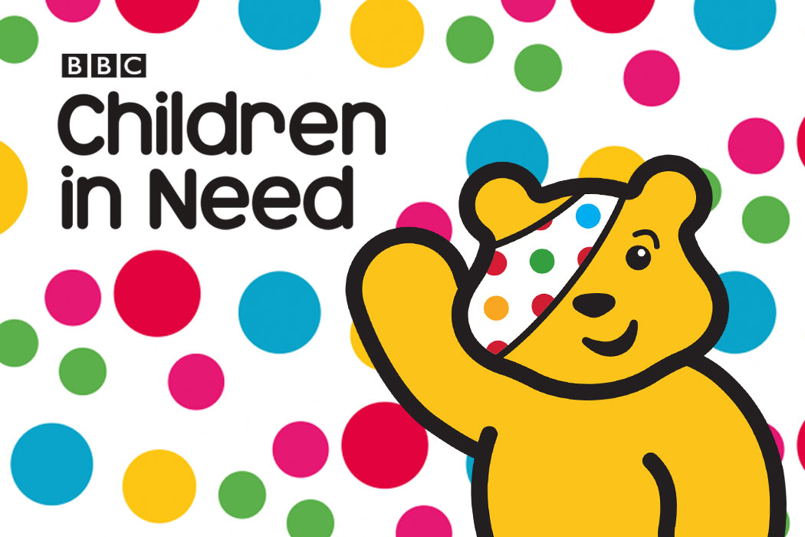

Tuesday 26th November – AGM – Open Evening

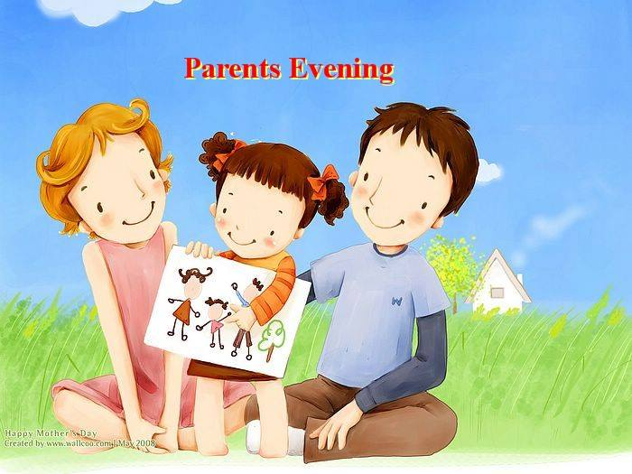
Saturday 7th December – Children’s Christmas party

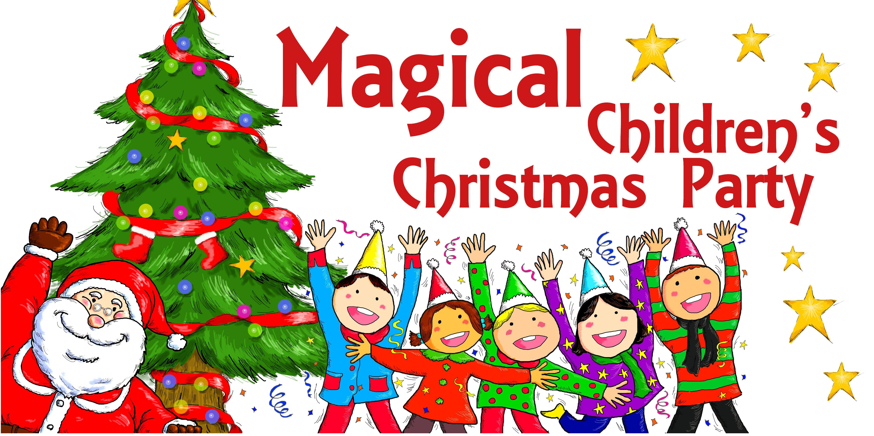

Tuesday 10th, Wednesday 11th and Thursday 12th December – Nativity Play performances



