Home Links
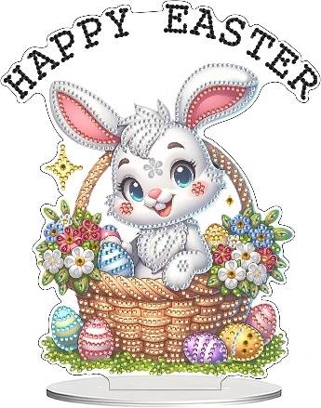

Welcome back, we hope you all had a lovely Half-term break. This half term we will be including activities about Chinese New Year, fairy tales, polar bears, wildlife, Mother’s Day, science, red nose day and Easter. We also include letter of the week, and we ask you to let your child bring an item from home beginning with the letter. (Please only bring an item beginning with the correct letter as we are starting early phonic sounds). The letters for the next half term are as follows:
Week 1 – 23rd February – Chinese New Year, Tell a fairy tale day, International Polar Bear Day – Letter V
Week 2 – 2nd March – World Wildlife Day, Holi, World Book Day – Letter W
Week 3 – 9th March – Science week - Letter X
Week 4 – 16th March – St Patrick’s Day, Global Recycling Day, Red nose Day – Letter Y
Week 5 – 23rd March – Easter - Letter Z

We break up for Easter on Friday March 27th and return on Monday 13th April
At every session, the children will have opportunities to play, learn, and explore in all areas of the Early Years Foundation Curriculum. The areas of Development are:
Prime Areas – Communication and language, Personal, Social and Emotional Development, Physical Development
Specific areas – Literacy, Maths, Understanding the World, Expressive arts, and Design

