Home Links
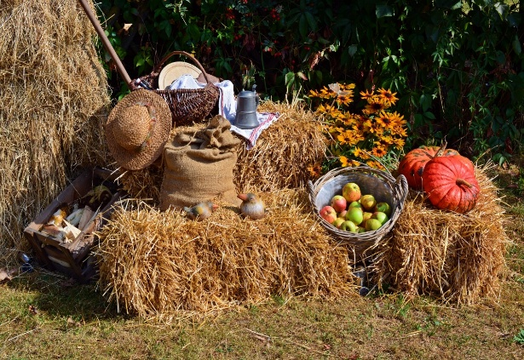

Welcome back, we hope you all had a lovely summer break. Welcome to all our new families joining us and a massive thank you to you all for the staff’s end of term gifts they were all very much appreciated. This half term we will be including activities about teddy bears, books, recycling, harvest festival, space, badgers, and autumn. On Friday 25th September we will be hosting a McMillan coffee morning. We also include letter of the week, and we ask you to let your child bring an item from home beginning with the letter. (Please only bring an item beginning with the correct letter as we are starting early phonic sounds). The letters for the next half term are as follows:
Week 1 – 2nd September – no official planning – Letter A
Week 2 – 7th September– Teddy Bear Day – Letter B
Week 3 – 14th September – Book and story week - Letter C
Week 4 – 21st September – Recycling Week, McMillan Coffee Morning Friday 25th - Letter D
Week 5 – 5th October – Harvest Festival - Letter E
Week 6 – Space Week and National badger day – Letter F
Week 7 – 12th October - Autumn – Letter G
We break up for the autumn half-term break on Friday 16th October for two weeks and return on Monday 2nd November
At every session, the children will have opportunities to play, learn, and explore in all areas of the Early Years Foundation Curriculum. The areas of Development are:
Prime Areas – Communication and language, Personal, Social and Emotional Development, Physical Development
Specific areas – Literacy, Maths, Understanding the World, Expressive arts, and Design

